Now vary the packet size and observe the metrics. Take packet size [128,256,512,1024,2048] bytes and collect the throughputs for each of them. Plot the packet size vs Throughput in this case and explain the graph.

Answer → Here is the screenshot of all different data packets and its throughputs.

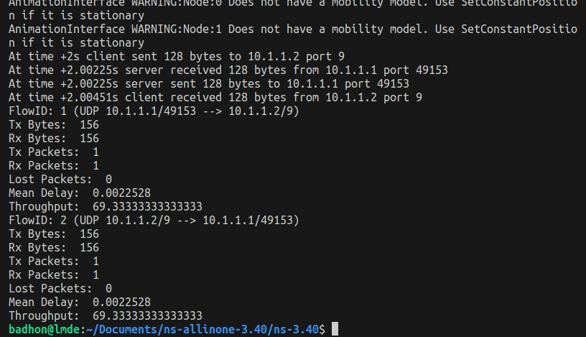
Image of packet size 128

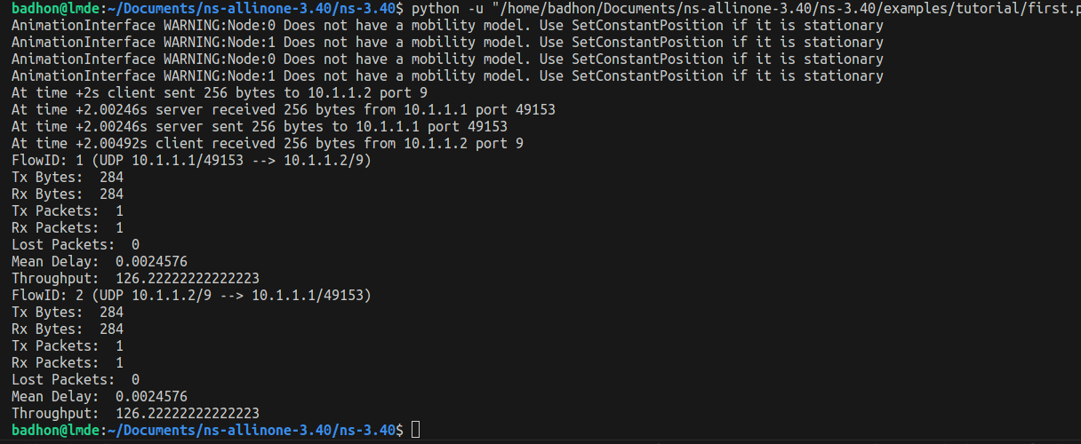
Image of packet size 256
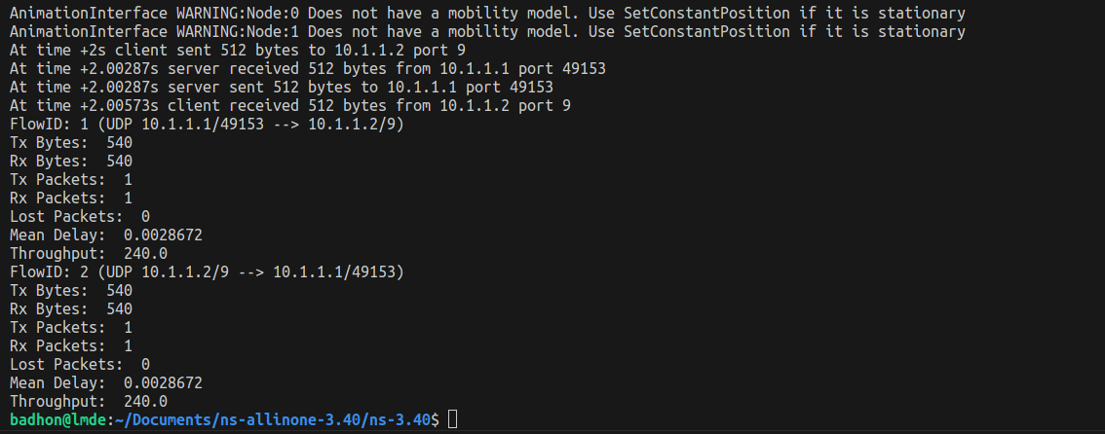
Image of packet size 512

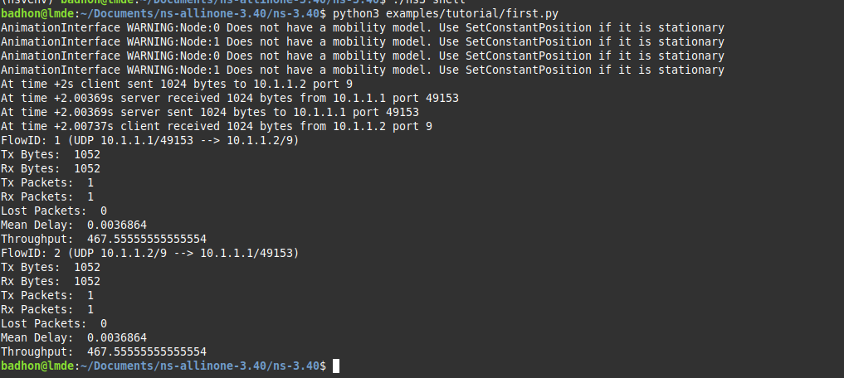
Image of packet size 1024

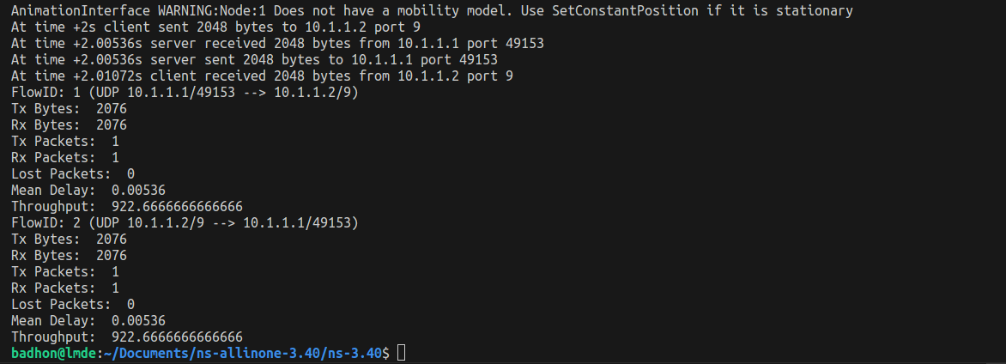
Image of packet size 2048
Here, the X axis will be packet, and the Y axis will be throughput. So the coordinates will be (128, 69.33), (256, 126.22), (512, 240), (1024, 467.56), and (2048, 922.67).
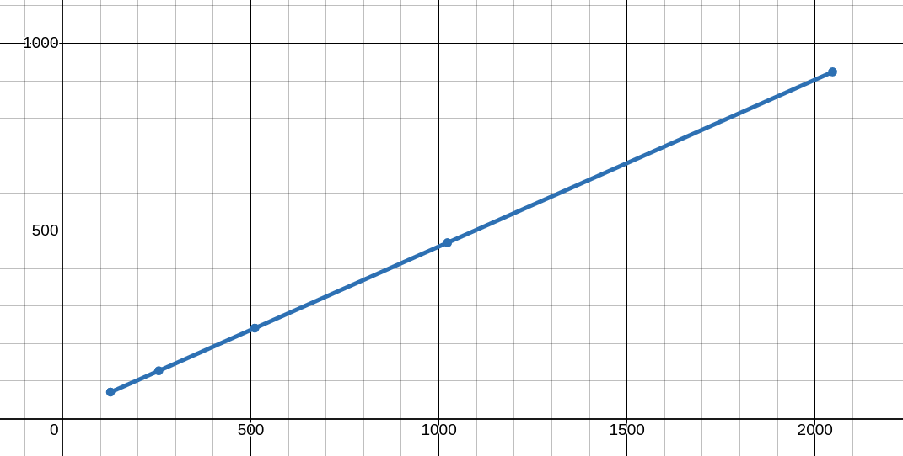

Graph Link: https://www.desmos.com/calculator/b5sktzakqt
This graph shows throughput increases with the packet size.

